Target distribution
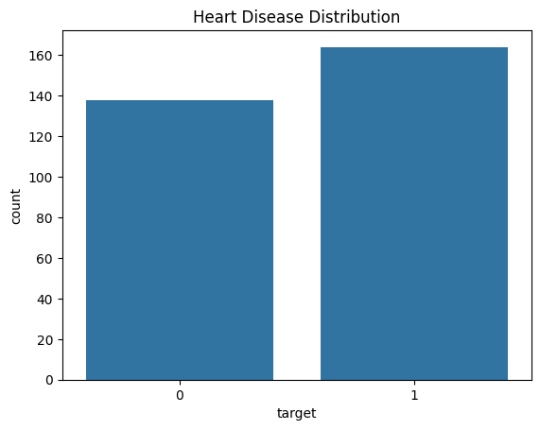
Age distribution
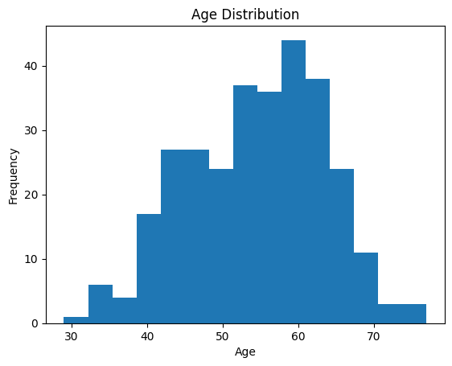

Cholesterol Distribution
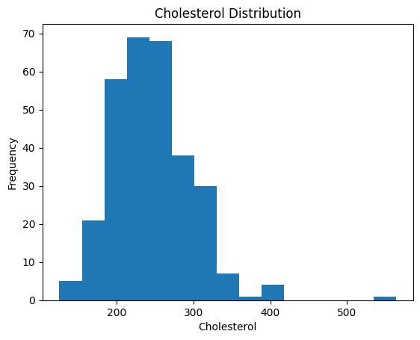
Boxplot for Outliers
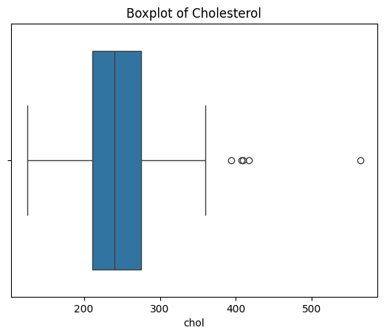
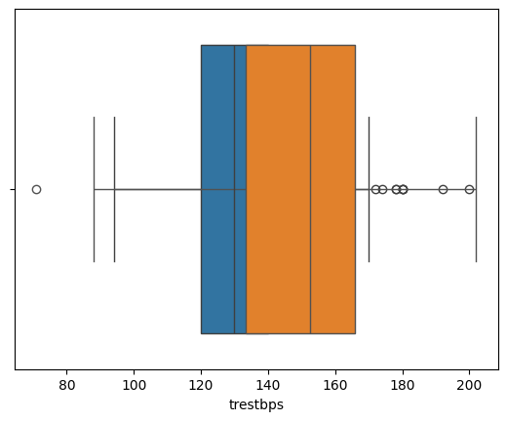
Scatter Plot (Age vs Max Heart Rate)
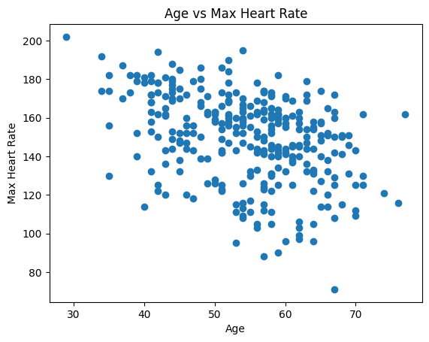
Correlation Heatmap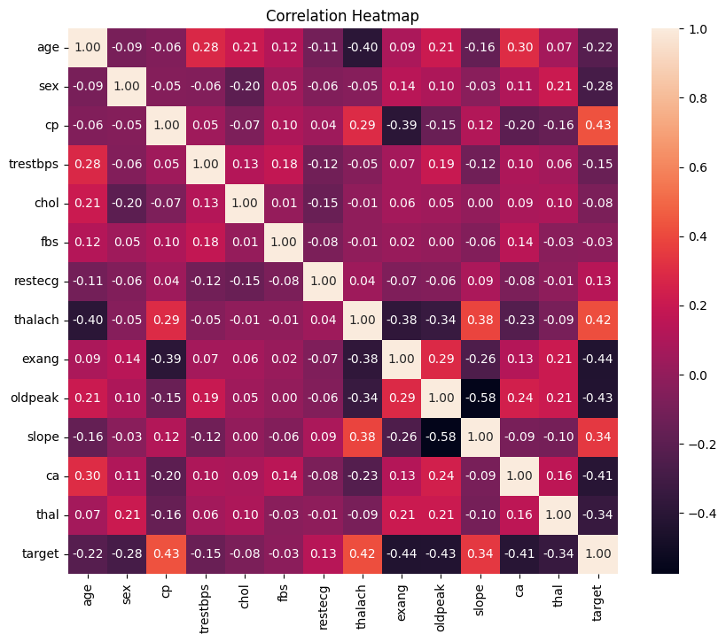
Summary

The data includes both clinical and demographic data of patients utilized in predicting the existence of heart disease. The data comprises 303 observations and 14 variables such as age, sex, cholesterol level, resting blood pressure, maximum heart rate and target variable.
Descriptive statistics indicate that the mean age of patients is the average of middle-aged and older people. Cholesterol and resting blood pressure is different in individuals. The dataset did not have any significant missing values. Duplicates records were eliminated in a few cases.

Important insights were drawn in terms of visualizations. Most patients are between the ages of 40 and 60 years as indicated in the histogram of age. The cholesterol distribution has weak skewness of right and few extreme values. Boxplot showed that cholesterol and resting blood pressure had mild outliers. Scatter plot of age versus maximum heart rate indicates that there is negative correlation between age and maximum heart rate i.e. maximum heart rate decreases with age.
The correlation heatmap reveals that maximum heart rate (thalach), the type of chest pain (cp) and exercise-induced angina significantly relate to heart disease.
Generally, the dataset is not very messy, and very little preprocessing should be carried out. Once the duplicates are eliminated and the outliers addressed, the data is now predictive model ready.

